|  |
| --- |
| Qatar University |
| CMPT 561 Web development |
| Assignment 1 |

|  |
| --- |
| Abdelrahman Shouman  10-24-2015 |

# Login.html

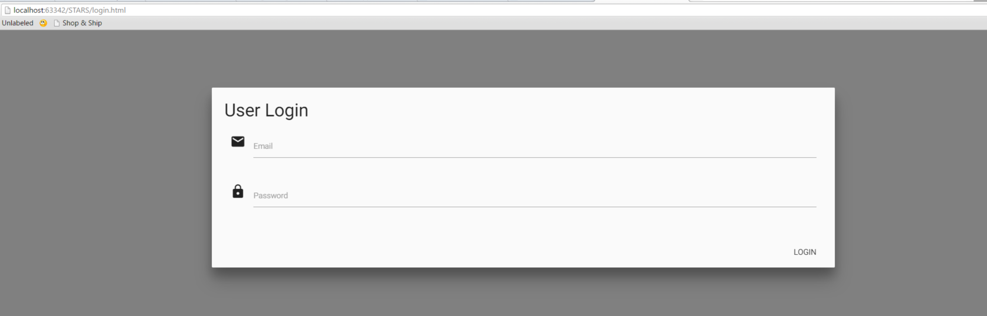

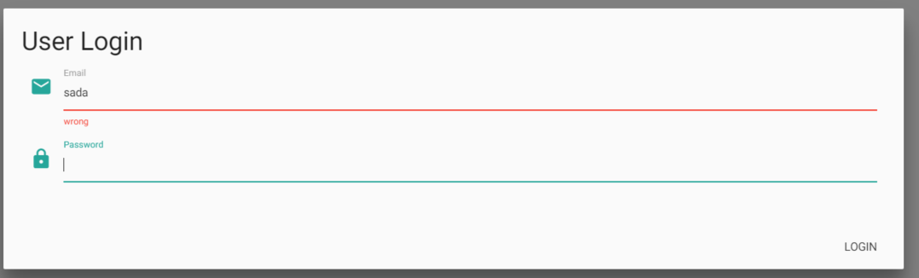

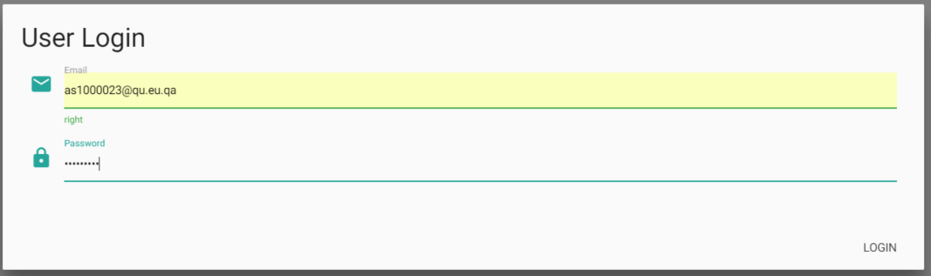

# Stars.html

## List of all students

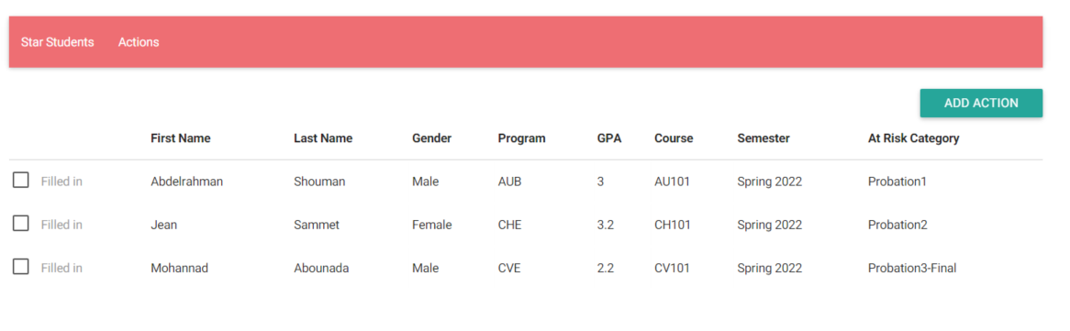

## Add actions on the same page

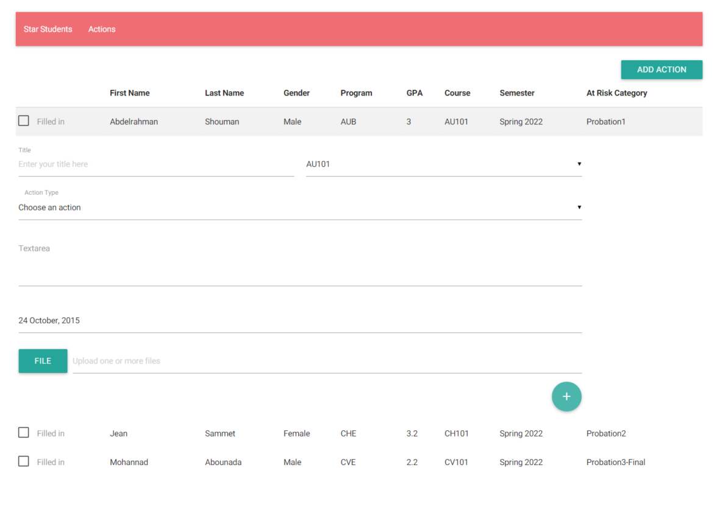

## List of actions

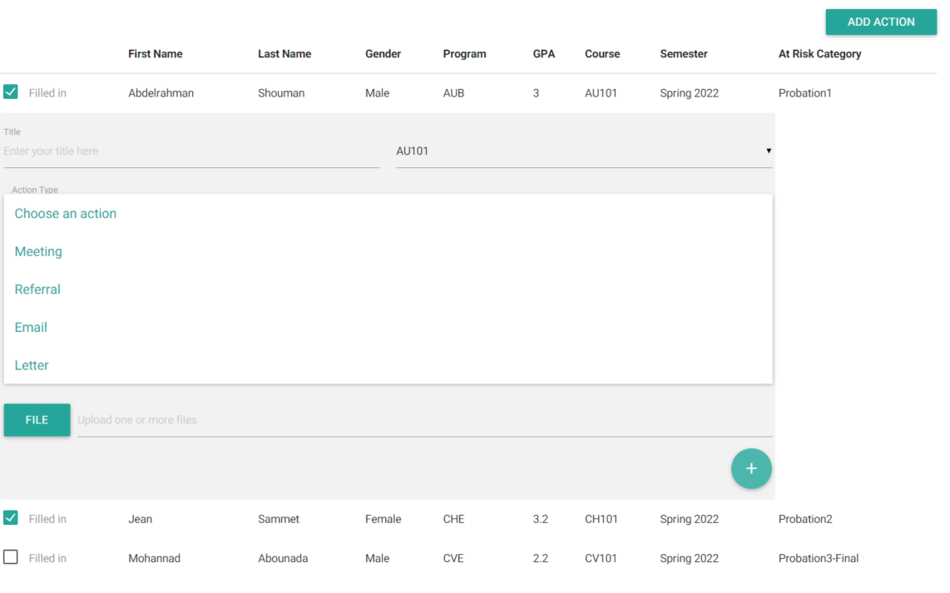

## Date

Default is today

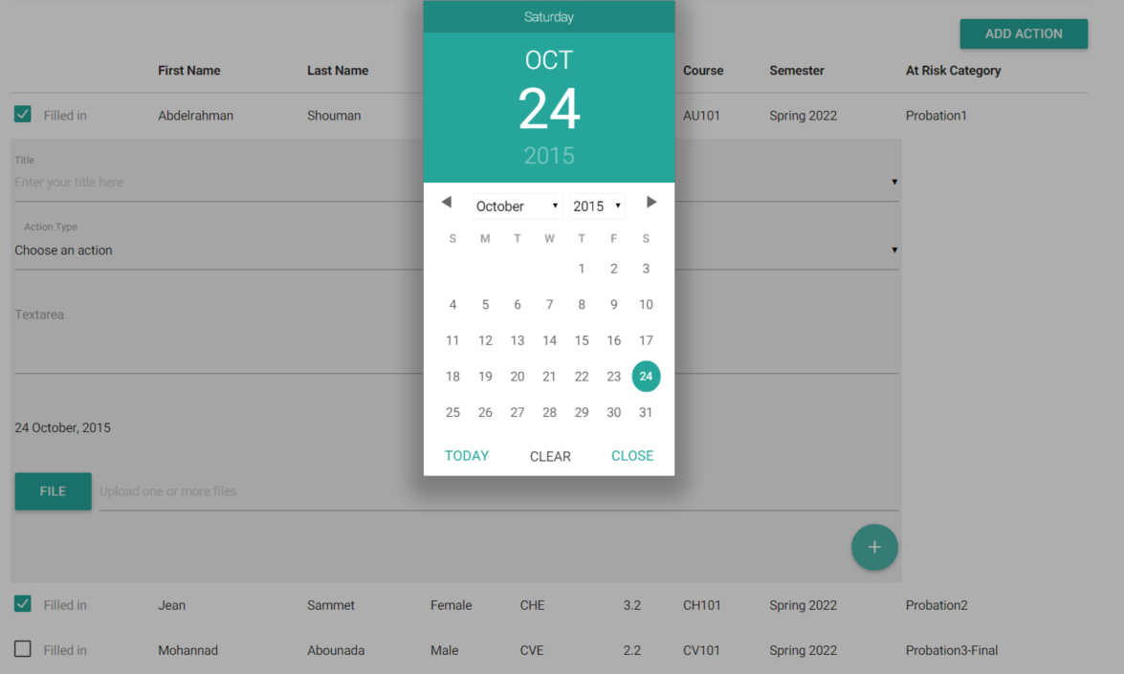

## Upload attachment

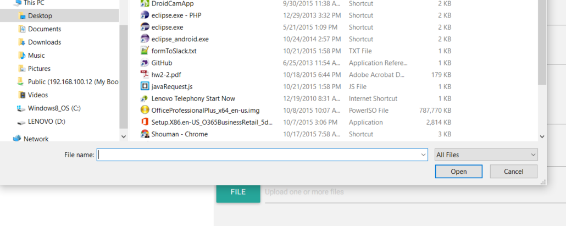

## Add action for multiple students

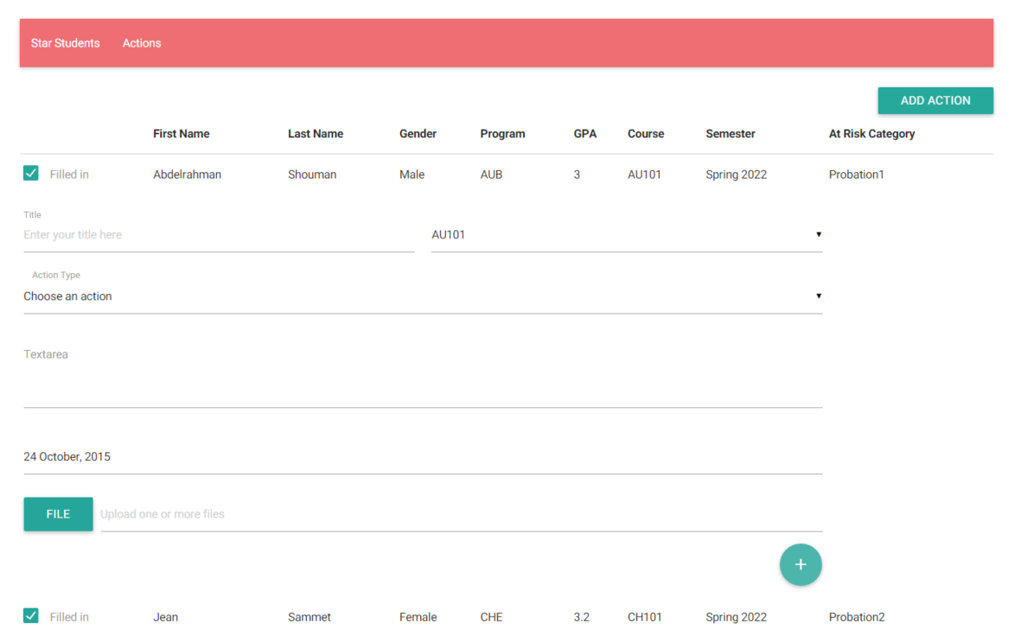

## Adding action

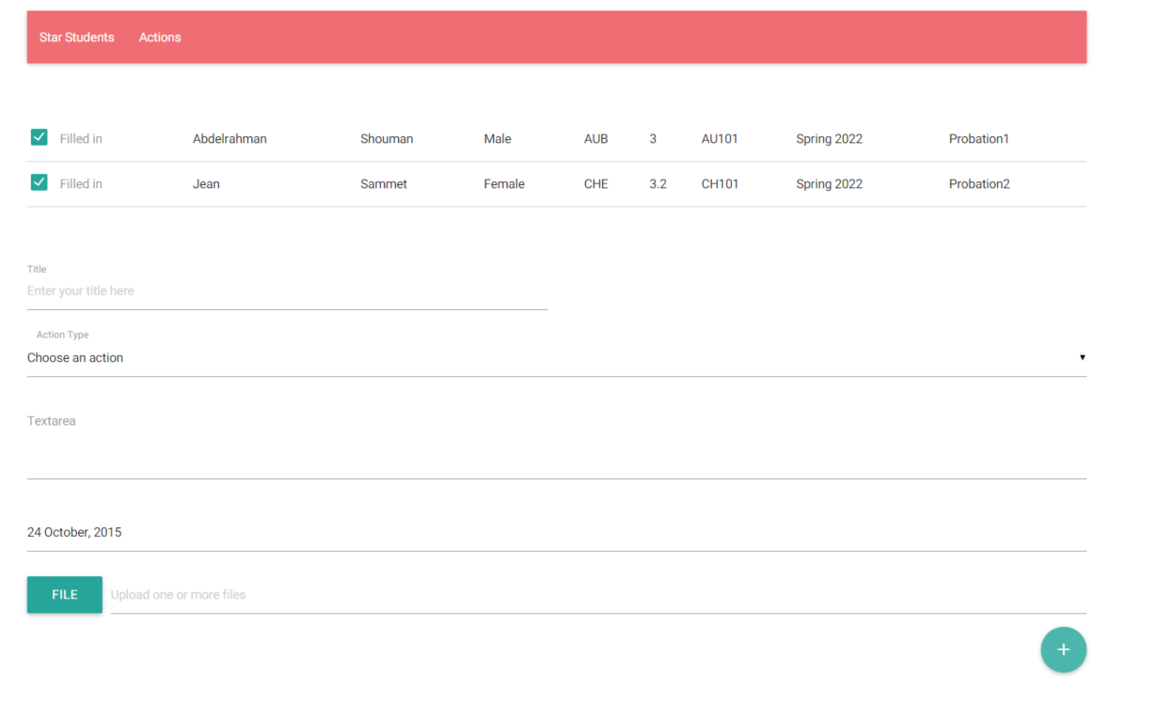

# Actions.html

Navigate between students through navigation

